School Council Meeting Minutes
September 21st, 2026
In Attendance: Jackie Kraemer, Daelynn Takasaki, Charmaine Uys, Danille Lazzaratto-Green, Andrea Koester, Kurt Leiblich, Jake, Janine, Monalisa Caborera, Jose Relacion, Brody Prete, Lindsey Prete, Chantele Motycka, Asheley Conie, Malorie Enns, Heather Wirzba, Tricia Doherty (trustee Representative), Mildred Fou, Roisin Gibb.
a.) Prayer
In the name of the Father, and of the Son, and of the Holy Spirit. Amen.
Heavenly Father,
Thank You for bringing us together as a school community. As we begin this year, help us to “Open Wide the Doors”—opening our hearts, our minds, and our school to Your presence and Your love.
Help us to know You, love You, and serve You through the work we do for our students and families. Give us wisdom, compassion, and open hearts as we listen, share, and work together.
May everything we do tonight help build a school community where every child knows they are loved, valued, and welcomed.
Amen.
b.) Land Acknowledgement – Jackie
Before we begin, I would like to acknowledge that the land on which we reside is the traditional Blackfoot Confederacy territory. We honour the Blackfoot people and their traditional ways of knowing and caring for this land, as well as all Indigenous Peoples who have helped shape and continue to strengthen our St. Francis community.

St. Francis Junior High School
Annual General Meeting 2026
Monday, September 21, 2026 from 5:00pm-6:00pm
1. Call to order – 5:00pm – Charmaine Uys
a.) Opening Prayer – Jackie Kraemer
b.) Land Acknowledgement – Jackie Kraemer
2. Welcome and Introductions
3. Approval of Annual General Meeting Agenda
Motion: Moved by Chantele, seconded by Lindsey, the approval of Annual General Meeting Agenda.
Carried.

4. Approval of previous AGM minutes
Motion: Moved by Danille, seconded by Lindsey, the approval of previous AGM minutes.
Carried.

5. Chair’s Report – Charmaine Uys
-Update for 2025/26 School year:
- School council met for regular meetings
- school Council reviewed By-Laws and updated them
- Year book wasn't available this year- made Jackie aware and implemented a plan to have it available for 2026/27 school year.
- Brought awareness around anxiety and around exams from scholars due to the strike. Teachers were able to address this and put minds at ease.
- School Council discussed parents' concerns about the late message system at Holy Spirit School Division. Safe Arrival implemented.
- $3000 gifted towards 2025/26 Academic Awards Ceremony
- Staff appreciation lunch provided to the teachers
- School Council members partook in Value Scoping Workshop for the potential new school build/modernization.
6. Treasurers Report – Danille Lazzaretto
See atttached
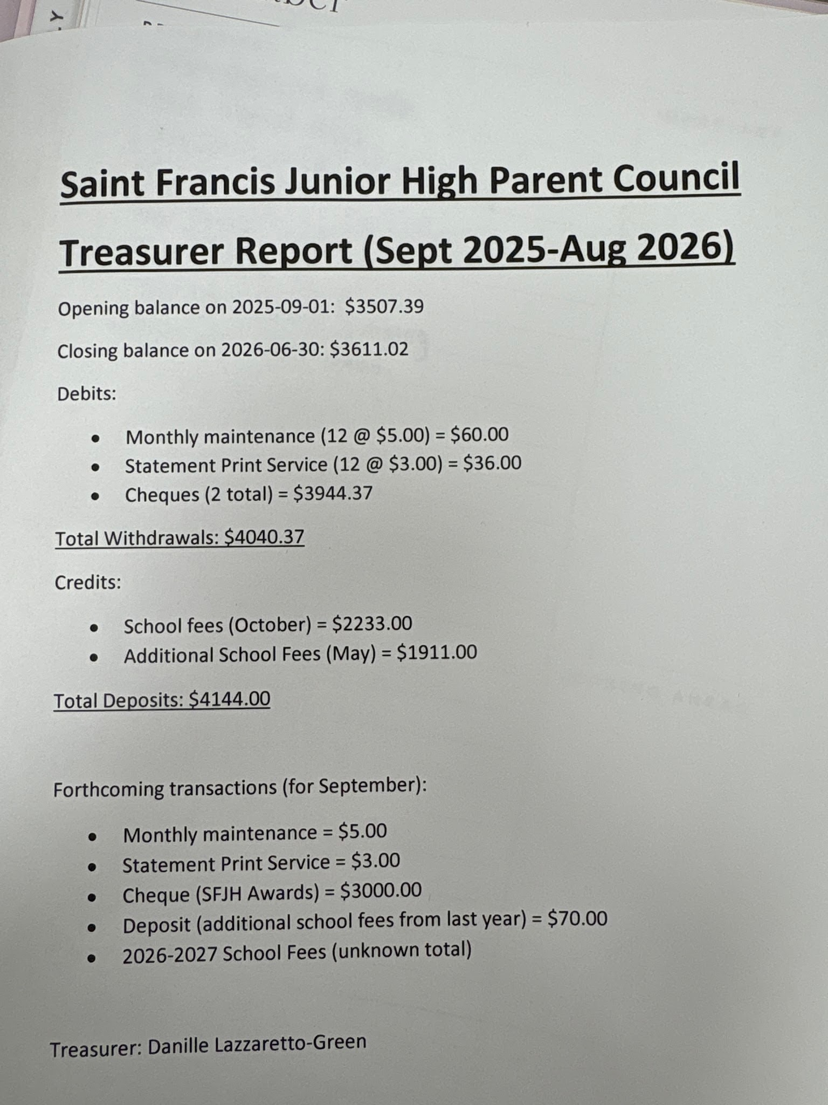
7. Executive Committee Elections:
a. Chair- Charmaine Uys
b. Vice-Chair- Daelynn Takasaki
c. Secretary- Lindsey Prete
d. Treasurer-Danille Lazzaretto- Green
8. Adjournment- 5:15

September School Council Meeting
Monday, September 21, 2026 from 5:30pm-6:00pm

1. Approval of minutes from May 2026 School Council Meeting.
Motion: Moved by Chantele, seconded by Danille, approval of minutes from May 2026 School Council Meeting.
Carried

2. Trustees Report – Tricia Doherty
- Government announced complexity teams for Junior and Senior High- Consists of a teacher and two EA’s. To be determined what schools they will be placed out of, but will be one junior high and one senior high.
- A second tour occurred with the government and members of the board regarding the proposal for a rebuild/modernization.
- Catholic Education on Sunday on Oct. 18. Calgary Diocese will double any contributions of individual parishes towards Catholic Education week.
3. Principal’s Report – Jackie Kramer
- Staffing Updates:
  - Aimee Baron
  - Tyson Cote
  - Kyra Rowe
  - Jared Sandham
  - PS III Interns - 3
  - returning - Kristen Laurie, Griffin Dyck, Sarah Mucha, Morgan Boyes

- Enrollment Updates
  - total 721

- School Tours
  - Minister Long Infrastructure
  - MLA Neudorf
  - Mayor of Lethbridge
  - Delegates from Holyspirit at Leth SD
  - Alberta Education date set for Sept 21

- Office Hours/ Parent Teacher Interviews
  - Office Hours posted on our website - call the office to book in.
  - Interviews on October 15th - google calendar

- Fine Arts Updates:
  - Show will be announced in next couple of weeks
  - Christmas concert date - December 15, 2026

- Athletics
  - Cross Country
  - Volleyball

- Division Pow Wow - October 8, 5:00-7pm at Children of St. Martha’s
  - All families welcome to attend

- New Curriculum Pilot
  - Math
  - Social

4. Old Business:
- Donation of $3000 to Awards Night – paid to school. Awards night- Oct. 19
5. New Business:
- Review proposed school council meeting dates for the upcoming
- Nov. 10- 6:00pm
- Jan. 12- 6:00pm
- March 9- 6:00pm
- May 11- 6:00pm
2026/2027 year.
b. Outline initial goals or key focus areas for 2026/2027.
- School Council Grant- Discussion on what to do with this year with funding. Some ideas included- Blanket exercise, Campfire chat with Elders, information sharing for grade 8 and 9 students around course selection for high school. Potential career type of event with post-secondary representatives and invite CCH Career Counsellor to provide some information. Charmaine will put together a few ideas and present at the next meeting.
- Chocolate sales will hopefully begin Oct. 1-Oct. 30. Jackie is waiting to hear confirmation of the dates and will send out consents.
- The Student Council will plan for a staff appreciation lunch again this year, as well as awards.
6. Closing Prayer – Jackie Kramer
7. Adjournment- 5:45pm

